Curriculum vitae
Key ATTRIBUTES

Hard-working
Team-working
Communication
Determination
Enthusiastic
Problem solver

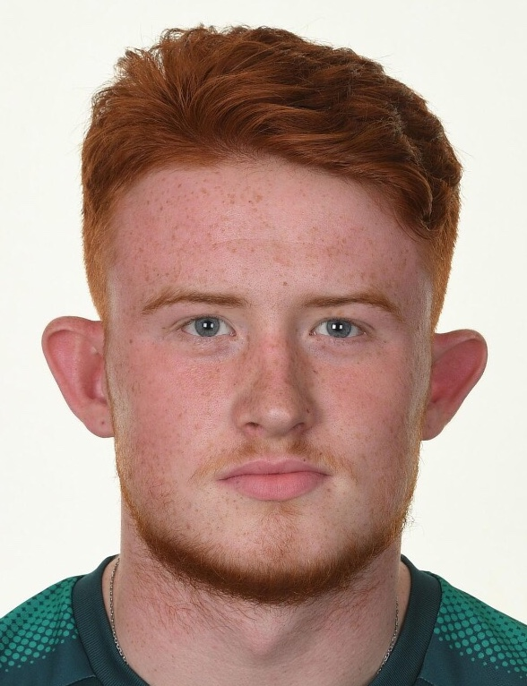

Alex crean

152 Beckenham Road

Beckenham, Kent

BR3 4RJ

M: 07730 670 858

E: creano83@outlook.com

PERSONAL STATEMENT

As a person, I am results driven. I am always looking to see how I can improve and develop. I am also a team-player having lived and operated within elite sporting environments for much of my life and understand the importance of collaboration and working together and communication. I have experience of both elite sports, and of working away from the sporting environment – having demonstrated resilience and adaptability as key attributes, whilst transitioning from a full-time professional playing career to one in working full-time in engineering and then moving into the finance industry.

I have just finished studying for a degree that provides business skills for football at the University of Salford. As part of my degree, I learned about key aspects of the football industry, including leadership, talent development and psychology, with practical business skills. My objective is to develop a full-time career which builds upon the skills attained from my degree, particularly in recruitment, communication, problem solving and business management, in the future I would like to carry on my education and do a masters in sports directorship.

In addition, I have been learning Spanish through a course sponsored by the Professional Footballers Association (PFA). I am keen to strive to be the best that I can be and to develop a wide range of skills and knowledge which will serve me well for my future life.

I have also completed the UEFA elite scout program where I was amongst some of the most talented scouts and sporting directors in the game and who’s knowledge and expertise where excellent to learn and gain experience from this included Andre villas-Boas former Porto Chelsea and Tottenham manager and Frederic Massara former AC Milan sporting director.

Working in scouting and recruitment at first team level in The English Football league, analysing players putting reports together to describe the player saying how they will fit into systems and seeing the current and future potential, then relaying the information I have found on them alongside the report and presenting to the Head of recruitment and manager on why we should pick this player.

eMPLOYMENT

- Working on Billingsgate fish market packing and selling fish to trade and Buyers.
- Scout Reports for Trabzonspor FC and Omonia Nicosia regarding players they are interested in, in the UK.
- Crewe Alexandra Football Club - Live and video First team Scout July 2023 -
- Academy Member St. James’s Place Financial Services Nov 2022 - Sept 2023
- Sevenoaks Town FC First Team Goalkeeping Coach June 2022 – Sept 2023
- Glebe Football Club First Team Goalkeeping coach June 2021 – June 2022
- Wetworks Engineer @ K&T Heating Feb 2021 – June 2022
- Operations & Rehabilitation from Shoulder Surgery & Hip Surgery Feb 2019 – Dec 2019
- Professional Goalkeeper @ Arsenal Football Club (English Premier League) Sept 2016 – July 2018
- Contracted Goalkeeper @ Bromley Football Club (National League) Jan 2016 - June 2016
- Professional Goalkeeper @ Celtic Football Club (Scottish Premier League) July 2015 – Nov 2015

education

- University of Salford BSc Applied Football Studies Class 2 Division 1 degree Sept 2020 - May 2023
- Crystal Palace Academy at Oasis Academy, Shirley Road, Croydon, CR9 7A Sept 2013 – June 2015
- Bishop Challoner School, 228 Bromley Road, Shortlands, BR2 0BS Sept 2009 - Jul 2013

KEY SKILLS, REPRESENTATIVE ACHIEVEMENTS & KNOWLEDGE

- Obtained Level 1 and Level 2 coaching badges
- First-hand experience and knowledge of English Academy System (Category 1), having been a player at Crystal Palace FC and Arsenal FC.
- Provided coaching support to younger Academy goalkeepers at Crystal Palace, Celtic FC and Arsenal FC.
- Worked with Academy Team Managers and provided support for younger Academy teams at Arsenal FC on match days.
- Familiar with the Performance Management Application (PMA) process used at Academies by players and staff.
- Familiar with key football Academy areas such as EPPP and also the conditioning and development of young players (having studied this in detail at university course).
- Leadership and coaching and working with players to achieve the best they can be.
- Represented Scotland Youth u16 football Team.
- Represented Arsenal Reserves, Celtic Academy and Crystal Palace FC Academy Football Teams.
- Bromley Football Club 1st Team Player in National League @ age 16 years.
- Captained Crystal Palace and Celtic FC Academy teams and provided leadership, direction and support to all teams.
- Have strong IT skills: IT Literate
- Creative in digital design with good understanding of social media & networking sites
- Ability to take on board information and understand and implement coaching strategies through playing career and now to provide strategies to players.
- Learning Spanish through the PFA to broaden knowledge and also given the international nature of football.
- The use of Wyscout and Impect for data analysis, filtration and recruitment of football players.
- Selling to Trade and to customers

QUALIFICATIONS

- Applied Football Studies, Business in sport 2.1 BSC HONS degree at the University of Salford
- The FA level 1 intro to Talent ID
- The FA respect for coaches
- The FA disability football introduction
- Scottish FA (SFA) mental health in football
- Scottish FA (SFA) children’s wellbeing in football
- Scottish FA (SFA) Goalkeeper award
- Scottish FA (SFA) Goalkeeping level 1.2
- Scottish FA (SFA) Goalkeeping 1.3
- Idea Inspiring Digital Enterprise award
- Independent Financial Adviser R01 Rules and Regulations of regulated financial planning
- Independent Financial Adviser R05 Protection of regulated financial planning
- BTEC level 1 - 2 first diploma Sport Double grade Pass Pass at level 2
- Edexcel functional skills qualification in Mathematics level attained – level 3
- GCSE Passes in Science, English Language, Physical Education
- LinkedIn learning IT Skills.
- UEFA Elite Scout Programme, diploma in scouting.
- About to start a Data Analysis course with the PFA covering recruitment and coding, leaving with a diploma in Data Analysis.

INTERESTS & HOBBIES

- Goalkeeping, football, sport in general and keeping fit
- Coaching and player and team development (football)
- Golf.

PERSONAL INFORMATION

- Age 24 Years
- Date of Birth 22nd August 1999
- Clean Driving License.

LinkedIn Link - Link to LinkedIn Profile – https://www.linkedin.com/in/alex-crean-368758205/

